SQT UNIT – 1
1) Define Software Quality. Why is it important in SDLC?

Software Quality refers to the degree to which a software product meets the specified requirements, user expectations, and industry standards. It ensures the software is reliable, efficient, maintainable, secure, and user-friendly while performing its intended functions correctly under specified conditions.

A software product meets its stated and implied needs, satisfying both its functional requirements and non-functional attributes. It's not just about the code working correctly; it encompasses a broad range of characteristics that determine a product's value to its users.
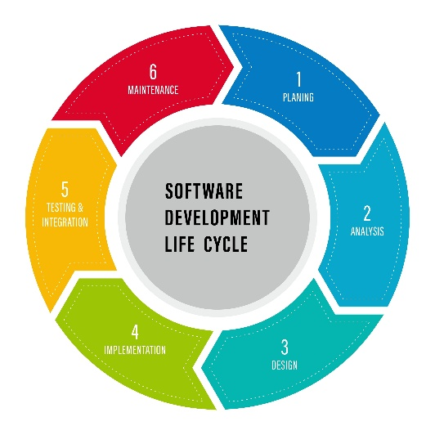

The Importance of Software Quality in the SDLC
Integrating quality assurance throughout the Software Development Life Cycle (SDLC) is not a mere formality but a strategic necessity. It transforms quality from a post-development afterthought into a foundational element of the entire process.
- Early Defect Detection and Cost Savings: The "cost of quality" principle dictates that finding and fixing defects early is far cheaper than fixing them later. A bug discovered during the requirements or design phase might cost a few hours of work, while the same bug found in production could cost thousands in lost revenue, customer trust, and emergency fixes.
- Mitigation of Technical Debt: Technical debt refers to the long-term consequences of making quick, low-quality decisions in the short term. Prioritizing quality from the start prevents the accumulation of technical debt, ensuring the codebase remains clean, maintainable, and scalable.
- Enhanced Customer Satisfaction and Brand Reputation: A high-quality product that is reliable, secure, and user-friendly leads to a better user experience, which in turn fosters customer loyalty and positive word-of-mouth. A strong reputation for quality is a significant competitive advantage.
- Improved Project Efficiency and Predictability: When quality is built in, testing cycles are shorter and more predictable. The team spends less time on rework and emergency bug fixes, allowing them to focus on new features and innovations. This leads to a more efficient and reliable development pipeline.
- Reduced Business Risk: Software failures can have serious business consequences, ranging from financial losses and regulatory penalties to data breaches and loss of intellectual property. A focus on quality minimizes these risks, ensuring business continuity and security.
- Compliance : Ensuring software quality also means adhering to various legal, industrial, and organizational standards. This can include data privacy laws (like GDPR), industry-specific regulations (e.g., in healthcare or finance), or internal company policies. Meeting these standards through rigorous quality checks is crucial for avoiding legal issues and maintaining business integrity.

2) Explain Cost of Quality (COQ) and its components?
The Cost of Quality refers to the total cost incurred to ensure that software meets quality standards.
It includes the cost of preventing defects, appraising quality, and fixing issues when they occur.
The goal is to deliver a high-quality product at minimum cost by balancing prevention and defect correction expenses.
The main goal of COQ is to:
- Deliver high-quality software at the lowest possible cost
- Minimize failure costs by increasing prevention and appraisal efforts
Formula :
COQ = Prevention Costs + Appraisal Costs + Internal Failure Costs + External Failure Costs
Components of COQ

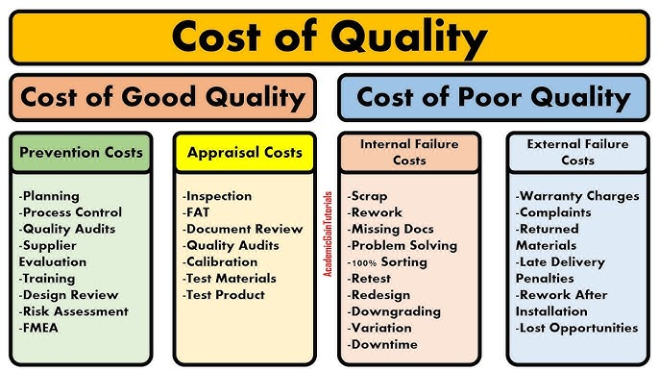

1. Prevention Costs
- These are the costs incurred to avoid defects before they occur.
- Focuses on proactive quality assurance activities.
- Examples:
  - Quality planning and documentation
  - Training and skill development for the team
  - Process improvement techniques (e.g., CMMI, Six Sigma)
  - Requirement reviews before development begins
Benefit: Fewer defects in later stages, leading to reduced rework and cost.
2. Appraisal Costs
- Costs related to measuring, monitoring, and auditing software to ensure quality standards are met.
- Involves testing and inspection activities.
- Examples:
  - Unit, integration, and system testing
  - Code reviews and walkthroughs
  - Quality audits and peer reviews
  - Test automation tools and QA infrastructure
Benefit: Detects defects early before the product reaches the customer.
3. Internal Failure Costs
- Costs due to defects found before product delivery to the customer.
- These defects are found during testing or reviews inside the organization.
- Examples:
  - Rework or modification of code
  - Debugging and retesting
  - Scrap or wastage of resources due to errors
Drawback: Though cheaper than external failures, it still increases development costs.
4. External Failure Costs
- Costs due to defects found after product delivery to the customer.
- These are the most expensive because they affect customer satisfaction and brand image.
- Examples:
  - Warranty claims and post-release bug fixes
  - Customer support costs
  - Legal penalties for non-compliance
  - Loss of reputation and future business
Drawback: Very expensive and can harm the organization’s credibility.
3) Compare: Quality vs Reliability vs Security vs Maintainability?
Quality
Software Quality is a broad, overarching concept. It's the degree to which a software product meets both its stated and implied requirements and satisfies user needs. Quality isn't a single attribute but a sum of many characteristics, including reliability, security, maintainability, performance, and usability. A product can't be considered high-quality if it lacks in one of these key areas.
- Analogy: Quality is like the overall health of a person. You can't say someone is healthy if they have a strong heart but are constantly getting sick or are prone to injury. Health is a combination of many factors like cardiovascular strength, immunity, and physical resilience.

Reliability
Software Reliability is the probability that a software system will perform its intended functions without failure for a specified period under specified conditions. It's about consistency and dependability. A reliable system is one that you can count on to work correctly every time. Reliability is a key component of overall software quality.
- Analogy: Reliability is a person's dependability. If someone says they will meet you at a certain time and place and consistently does so without fail, they are reliable.

Security
Software Security is the degree to which a software system protects data and functions from unauthorized access, use, or modification. It's about preventing cyber threats, vulnerabilities, and attacks. A secure system ensures data confidentiality, integrity, and availability. Security is a critical subset of quality, especially in today's digital world.
- Analogy: Security is a person's vulnerability to harm. A secure person protects their personal information and is aware of their surroundings to avoid being taken advantage of or harmed.

Maintainability
Software Maintainability is the ease with which a software product can be modified to fix defects, improve performance, or adapt to a changing environment. This attribute is crucial for the long-term health of a project. A maintainable codebase is well-structured, easy to understand, and can be changed without introducing new problems.
- Analogy: Maintainability is a person's ability to adapt and fix problems. A maintainable person can easily adjust to new situations or environments and can quickly recover from setbacks or injuries.
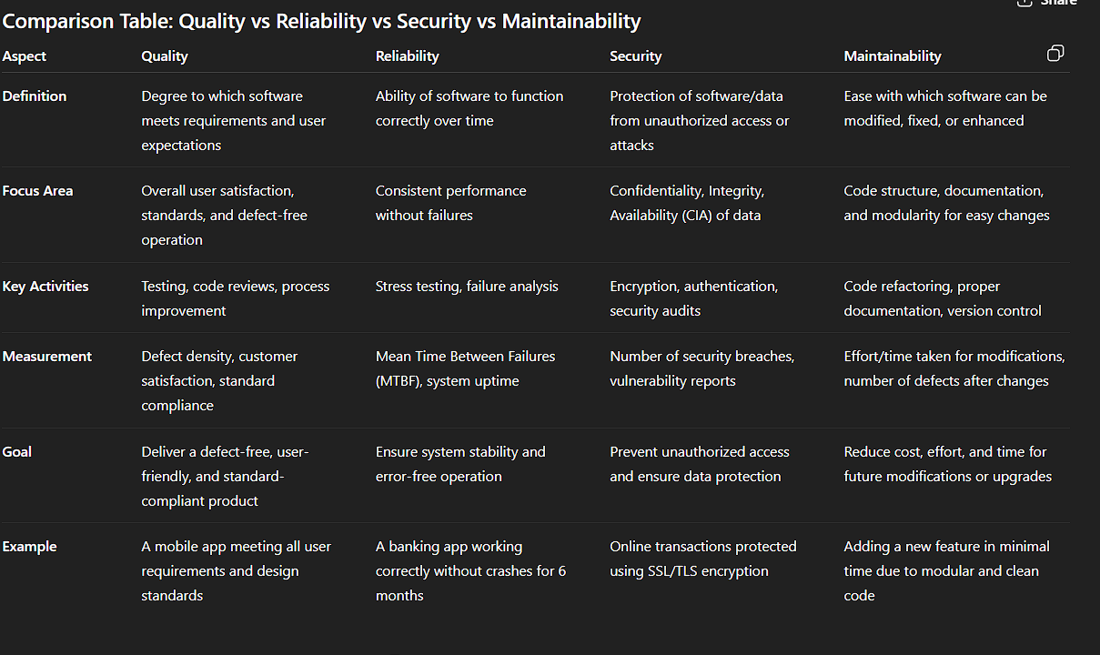

4) Describe McCall’s Quality Model with its categories?
McCall's Quality Model is a hierarchical software quality model that classifies software quality factors into three broad categories. Developed in 1977, its main purpose is to provide a framework for evaluating software from both the user and developer perspectives. The model defines 11 key quality factors that are grouped into three categories.
Three major perspectives for defining and identifying the quality of a software product:
- Product Revision (ability to undergo changes),
- Product Transition (adaptability to new environments), and
- Product Operations (its operation characteristics).

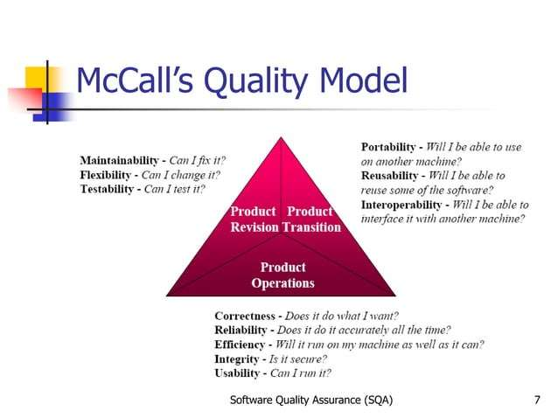

1. Product Operation Factors (How well the product works)
These deal with the day-to-day operational performance of software.

2. Product Revision Factors (How easy it is to change)
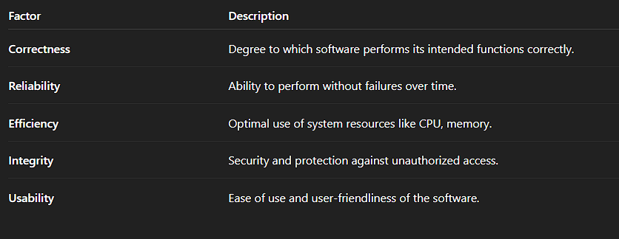

These deal with maintaining and updating software after deployment.
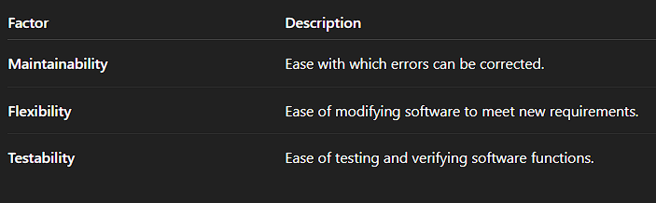

3. Product Transition Factors (How easy it is to adapt)
These deal with software adaptation to new environments or future changes.

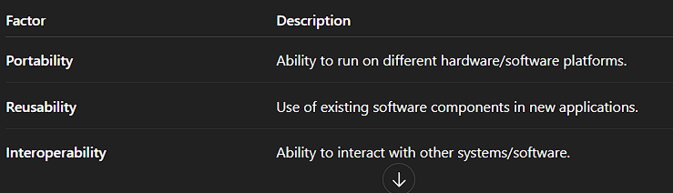

5) Compare McCall’s Model with Boehm’s Model (1978) and provide examples?
1. McCall’s Quality Model (1977) – Definition
McCall’s Model was one of the earliest models designed to bridge the gap between users and developers by focusing on software product attributes that determine quality.
- It defines three main categories of quality factors:
  - Product Operation → How well the software performs its functions.
  - Product Revision → How easy it is to maintain and modify.
  - Product Transition → How easy it is to adapt the software to new environments.
Objective: To produce software that meets user needs and product standards like correctness, reliability, and maintainability.
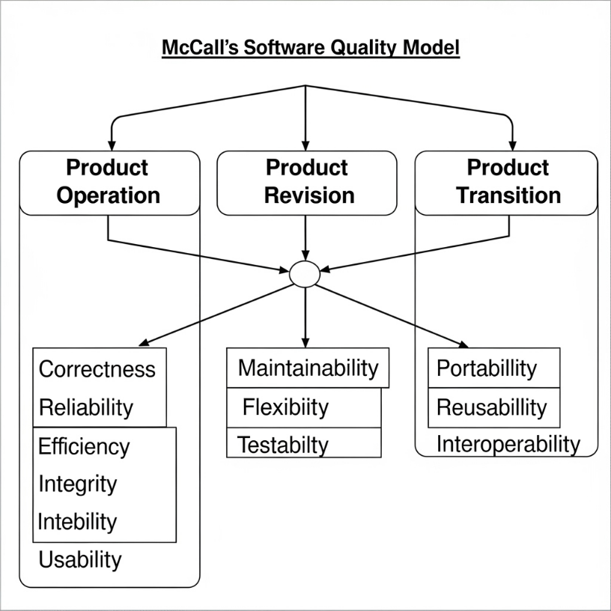

2. Boehm’s Quality Model (1978) – Definition
Boehm’s Model was introduced as an extension of McCall’s Model and provides a hierarchical structure for software quality.
- It defines quality at three levels:
  - High-level characteristics → As-is utility, Maintainability, Portability
  - Intermediate factors → Human Engineering, Efficiency, Reliability, etc.
  - Primitive factors → The actual measurable attributes affecting quality
Objective: To address both product quality and human factors like usability, human engineering, and maintainability for better user satisfaction.

Both McCall’s and Boehm’s models are early software quality models used to define, measure, and improve software quality.
- McCall’s Model (1977) focuses on product attributes and user views.
- Boehm’s Model (1978) extends it by adding more hierarchical and human-oriented quality characteristics.
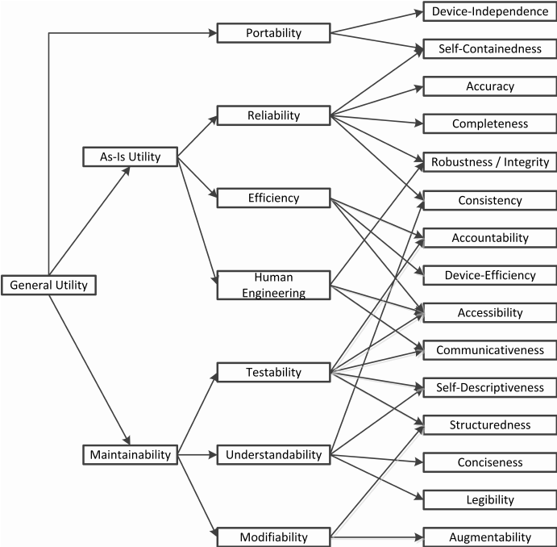

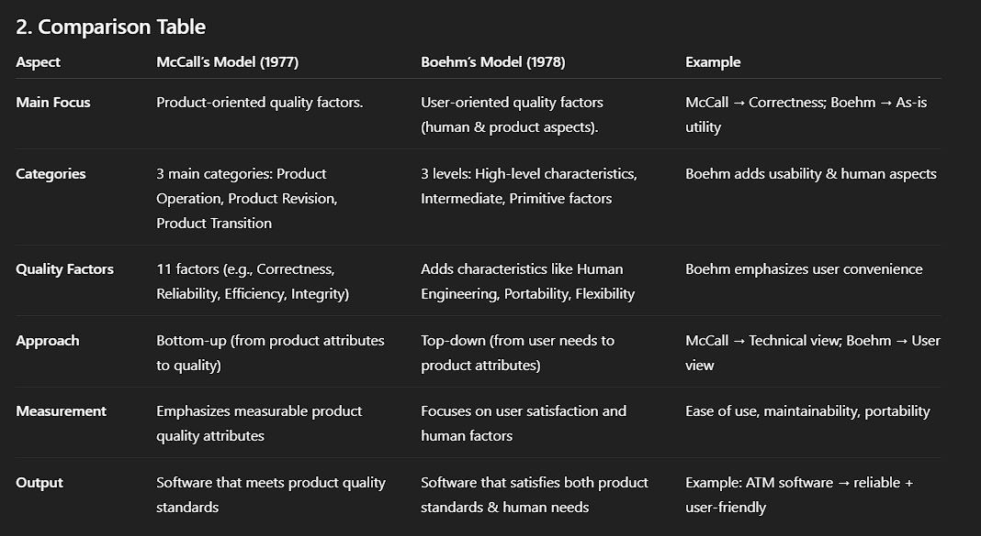

Examples of McCall’s Quality Model
Focuses mainly on technical quality attributes like correctness, reliability, efficiency, and maintainability.
- Banking Software
  - Emphasis on correctness (accurate transactions), reliability (no crashes), and efficiency (fast processing).
- Hospital Management System
  - Focus on data integrity (patient records accuracy) and maintainability (easy bug fixing and updates).
- Railway Reservation System
  - Ensures reliability (ticket booking works 24/7), efficiency (fast seat allocation), and security (safe payment processing).

Examples of Boehm’s Quality Model
Covers technical quality + human factors like usability, human engineering, and adaptability.
- Banking Software
  - Adds usability (easy for non-technical staff), adaptability (multi-language support), and training support for employees.
- E-Learning Platform
  - Considers user-friendliness, portability (access from mobile, desktop), and human engineering (attractive UI for better learning experience).
- Smart Home Application
  - Focuses on ease of use, adaptability (works on multiple devices), and maintainability (easy software updates for new devices).

6) Explain CMMI and its levels?
CMMI – Capability Maturity Model Integration
Definition
CMMI is a process improvement framework developed by the Software Engineering Institute (SEI) to help organizations improve their software development processes.
- It provides a structured approach for measuring and improving software quality and development maturity.
- The main goal is to deliver high-quality software products efficiently and consistently.

CMMI Maturity Levels
CMMI defines 5 maturity levels, each representing the organization’s capability in software development processes.

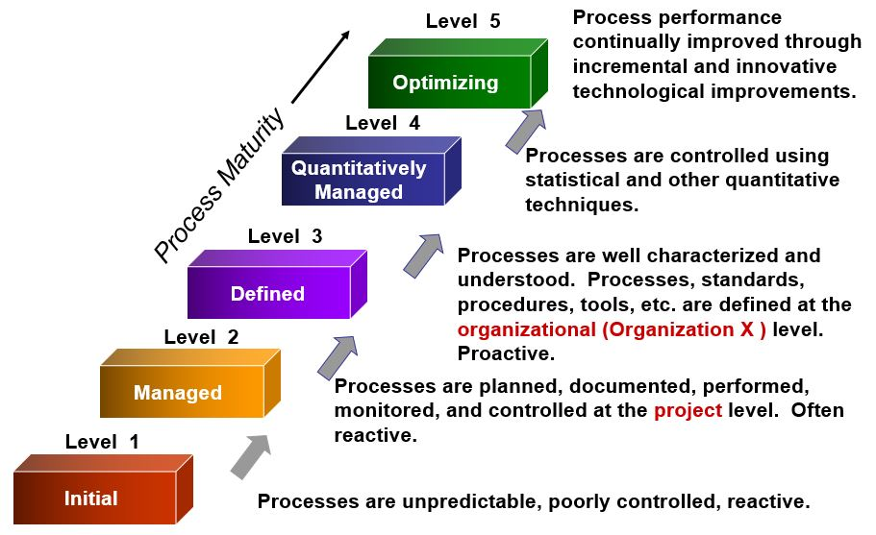
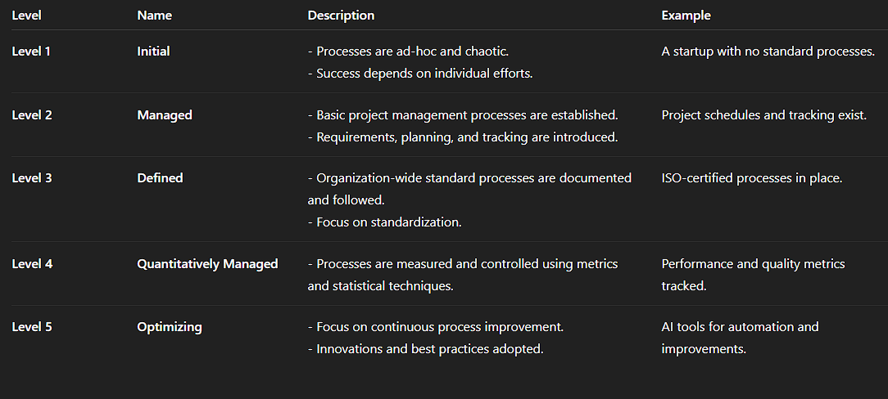

7) Differentiate between SQA, Quality Control (QC), and Testing?

1. Software Quality Assurance (SQA)
SQA is a process-oriented approach that ensures the entire software development process follows defined standards, procedures, and methodologies to prevent defects and maintain quality throughout the Software Development Life Cycle (SDLC).
Key Idea: "Prevention is better than cure."

2. Quality Control (QC)
QC is a product-oriented approach focused on checking the quality of the final software product by verifying whether it meets the required specifications and quality standards.
Key Idea: "Detect defects before delivery."

3. Testing
Testing is the execution of the software under controlled conditions to identify defects, errors, or gaps in the software so they can be fixed before release.
Key Idea: "Find defects by running the software."
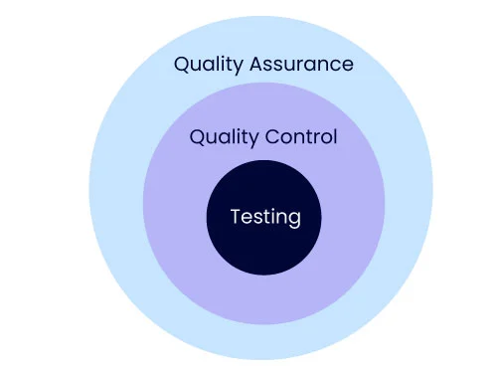

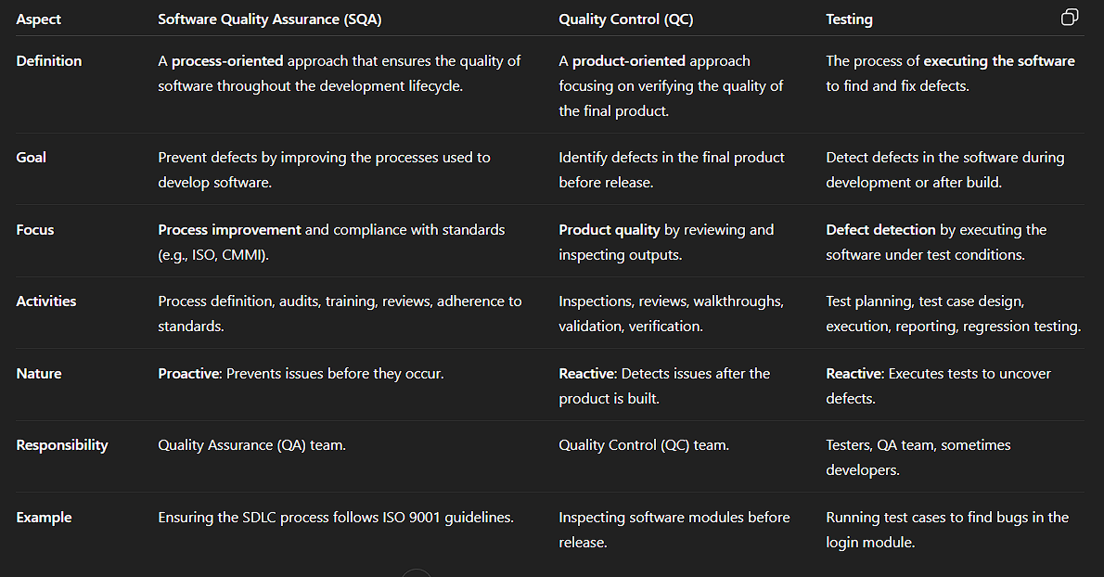

8) What are the roles and skills required for an SQA team?
The Software Quality Assurance (SQA) team plays a crucial role in ensuring the software meets quality standards, is reliable, and performs as expected before it reaches the end users. Here’s a clear breakdown of the roles and skills required for an SQA team:

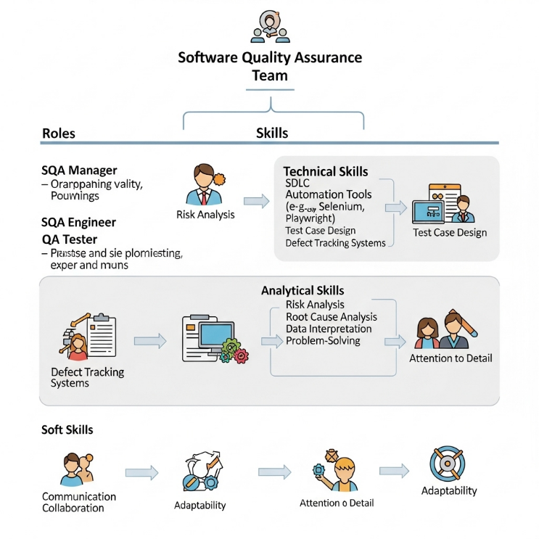

1. Roles of an SQA Team
The roles can be divided into planning, implementation, and reporting activities:
a) SQA Manager / QA Lead
- Defines quality policies, procedures, and standards.
- Plans and manages the overall QA process.
- Allocates tasks and monitors the performance of the QA team.
- Coordinates between development and testing teams.

b) SQA Engineer / Analyst
- Creates and maintains SQA plans, checklists, and audit procedures.
- Ensures compliance with SDLC, standards (e.g., ISO, CMMI), and best practices.
- Performs process audits, reviews, and risk analysis.
- Identifies areas for process improvement.

c) QA Tester / Test Engineer
- Designs test cases and prepares test data.
- Executes manual and automated tests to identify defects.
- Performs functional, performance, security, and regression testing.
- Reports defects and works with developers to ensure fixes.

d) Automation Engineer (Optional in some teams)
- Develops and maintains test automation scripts.
- Works with tools like Selenium, Cypress, or Playwright.
- Improves test coverage and reduces manual effort.

e) QA Documentation Specialist
- Prepares and maintains test plans, test reports, defect logs, and quality metrics.
- Ensures proper documentation for process audits and quality certification.

2. Skills Required for an SQA Team
Technical Skills
- Software Development Life Cycle (SDLC) and STLC knowledge.
- Familiarity with testing tools (e.g., Selenium, JMeter, Postman).
- Automation frameworks (e.g., TestNG, Cypress).
- Programming basics for automation (e.g., Python, Java, JavaScript).
- Database skills (SQL) for validating data.
- Defect tracking tools (e.g., JIRA, Bugzilla).

Analytical & Process Skills
- Requirement analysis to understand system specifications.
- Risk analysis for potential process or product issues.
- Root cause analysis for defects and failures.
- Knowledge of quality standards like ISO 9001, CMMI, Six Sigma.

Soft Skills
- Communication skills to interact with developers and stakeholders.
- Team collaboration and coordination.
- Time management and attention to detail.
- Problem-solving and critical thinking abilities.

Software Quality Assurance (SQA) has a major impact on software maintenance and reliability because it focuses on prevention of defects, adherence to standards, and ensuring high-quality processes during the entire Software Development Life Cycle (SDLC).

9) How does SQA impact software maintenance and reliability?

1. Impact on Software Maintenance
Software maintenance involves fixing bugs, updating features, and improving system performance after deployment. SQA influences maintenance in the following ways:
- Prevention of Defects
SQA ensures that processes followed during development are standardized and defect-free, reducing the number of bugs discovered after release.
Example: Code reviews, audits, and quality standards like ISO or CMMI help prevent errors early.
- Improved Documentation
SQA enforces proper documentation of requirements, design, and code. This makes future modifications and debugging easier and less error-prone.
- Better Change Management
SQA ensures proper version control, regression testing, and configuration management, minimizing risks while implementing changes.
- Cost Reduction
Early defect detection during the SQA process leads to fewer post-release issues, reducing maintenance cost and time significantly.

2. Impact on Software Reliability
Software reliability refers to the ability of software to function correctly under specified conditions for a defined period. SQA enhances reliability in the following ways:
- Process Compliance
By enforcing quality standards and guidelines, SQA ensures software is built consistently and predictably, leading to higher reliability.
- Rigorous Testing and Verification
SQA includes verification (reviews, inspections) and validation (testing) activities to ensure the software behaves as intended.
- Risk Mitigation
SQA identifies risks early through process monitoring and quality metrics, ensuring potential failures are prevented before deployment.
- Enhanced User Satisfaction
Reliable software leads to fewer crashes, accurate outputs, and better performance, increasing end-user confidence.

In Simple Terms
- SQA → Fewer Defects → Less Maintenance Work
- SQA → Strong Processes → Higher Software Reliability

10) Why is prevention better than detection in software quality?
Got it — let’s expand the explanation of "Prevention is better than detection" in software quality with more depth, examples, and insights so it covers every key aspect in detail.

Prevention vs. Detection in Software Quality
The principle "Prevention is better than detection" emphasizes that it is more efficient, cost-effective, and reliable to build quality into the software from the beginning rather than finding and fixing defects later in the development lifecycle.
Defects caught early are often simple misunderstandings or small errors in requirements or design. If undetected, these errors ripple through coding, testing, and deployment, causing delays, cost escalations, and product reliability issues.

Detailed Reasons Why Prevention is Better
1. Cost-Effectiveness
- Studies show:
  - Fixing a defect during the requirements phase = negligible cost
  - During design/coding = 2–5 times higher
  - During testing = 10 times higher
  - After deployment = 50–100 times higher
- Example:
A missing requirement in an e-commerce app’s checkout flow →
  - If found in requirements → Just update the document.
  - If found in production → Refunds, angry customers, downtime, developer overtime, and public image damage.
Conclusion: Early prevention drastically reduces development and maintenance costs.

2. Time-Saving
- Late detection triggers fix → retest → redeploy → revalidate cycles.
- This leads to missed deadlines and sometimes project failure.
Prevention through:
- Early requirements reviews
- Design inspections
- Static code analysis
These minimize delays by catching defects before coding or testing even starts.

3. Improves Software Reliability
- A software product with fewer defects during release will have higher stability, performance, and user trust.
- Prevention activities ensure that the root cause of defects is eliminated rather than just fixing the symptoms later.
Example:
Stress testing requirements identified early → Scalable architecture implemented → System handles large traffic smoothly.

4. Reduces Rework
- Every defect found late = More rework → More changes → More complexity.
- Prevention ensures requirements are clear, processes standardized, and designs validated before moving forward.
Result: Less back-and-forth, less confusion, and less chaos.

5. Better Resource Utilization
- If the team spends less time on defect fixes, they can focus on:
  - Adding new features
  - Optimizing performance
  - Improving user experience
- This improves overall team productivity and project ROI.

6. Minimizes Risk
- Prevention activities like audits, risk assessments, static analysis help identify:
  - Security vulnerabilities
  - Performance bottlenecks
  - Scalability risks
  - Regulatory compliance gaps
Fixing them early avoids catastrophic failures later.

7. Improves Customer Trust
- Customers prefer stable, bug-free software.
- A product delivered on time with minimal defects → Higher satisfaction → Brand loyalty → Positive reputation.

How Prevention is Achieved
Here are practical ways teams can achieve prevention rather than relying only on detection:
- Requirement Analysis & Reviews – Catch ambiguities before development starts.
- Design Audits – Validate architecture, performance, and scalability early.
- Adherence to Coding Standards – Enforce clean, consistent, and maintainable code.
- Automated Static Analysis Tools – Tools like SonarQube detect code smells before testing.
- Continuous Integration (CI) – Frequent builds and checks prevent accumulation of errors.
- Process Standardization – Follow ISO 9001, CMMI, Six Sigma guidelines.
- Peer Reviews & Walkthroughs – Fresh eyes catch defects developers might miss.

Comparison: Prevention vs. Detection
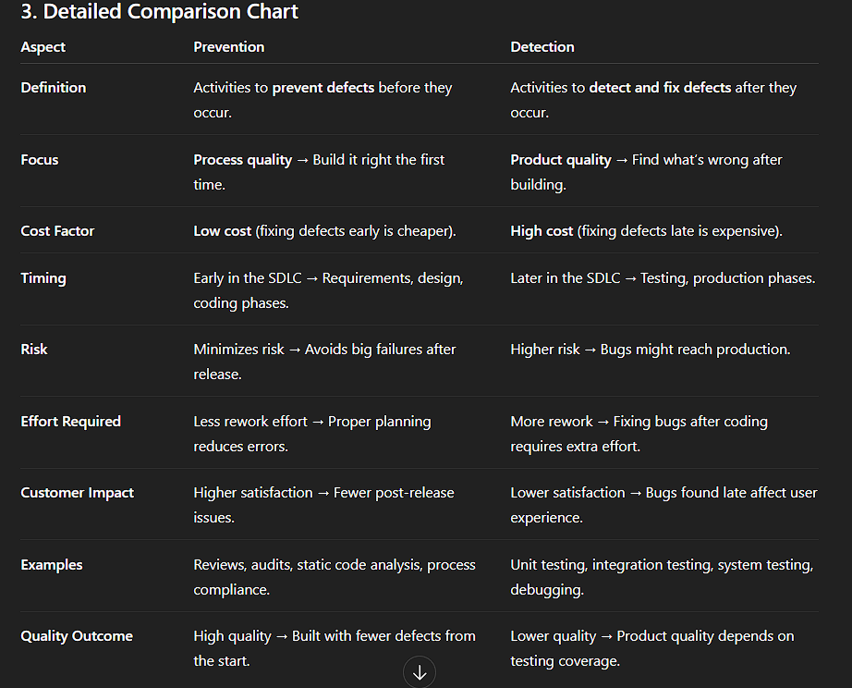

Real-World Example
- Without Prevention:
A banking application skips requirement reviews. Bugs found in production → Financial losses → Downtime → Negative press → High fix cost.
- With Prevention:
Same application follows SQA standards → Requirements clear → Design validated → Bugs minimized → On-time release → Customer trust intact.

